Bird Survey
Use this page to record the whereabouts and behaviour of birds.

 | Bird | Where seen (√) |  |  |  |  | Behaviour  (feeding, roosting, flying, etc)
 | Bird | the shore | in samphire | in water | in tree | in air | Behaviour  (feeding, roosting, flying, etc)
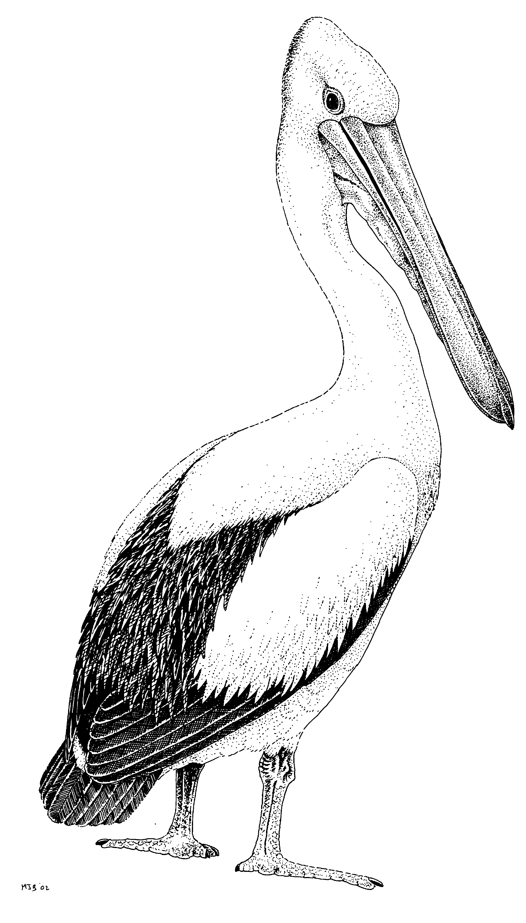 | Australian Pelican
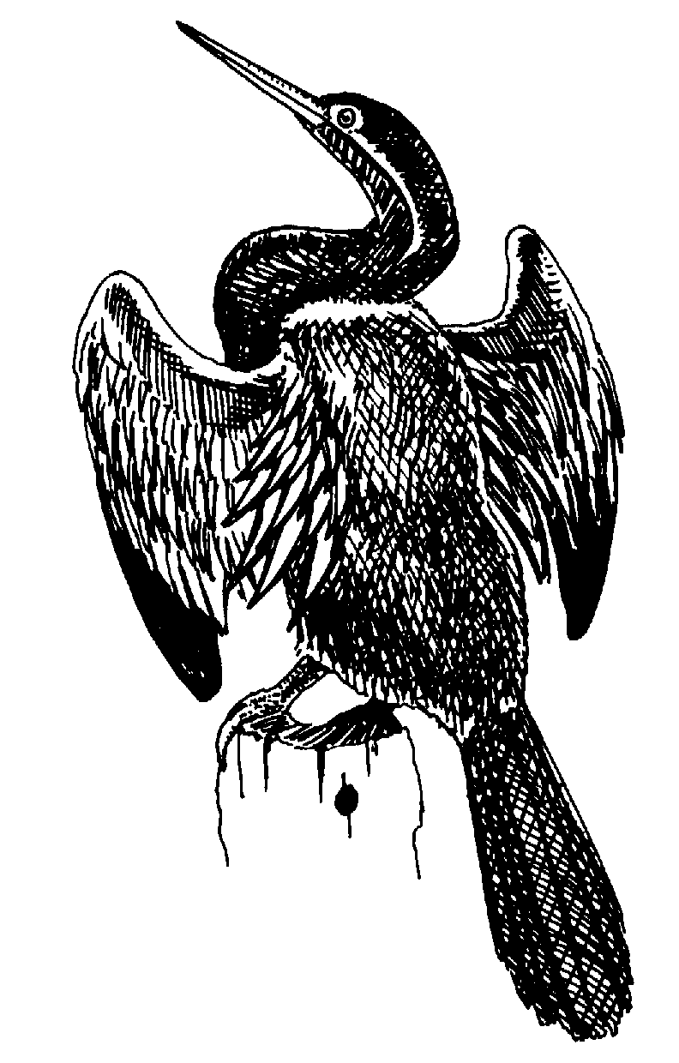 | Darter
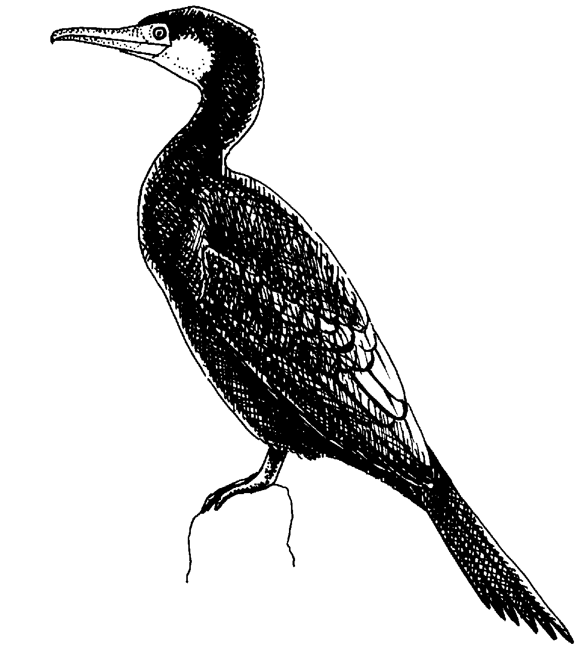 | Great Cormorant
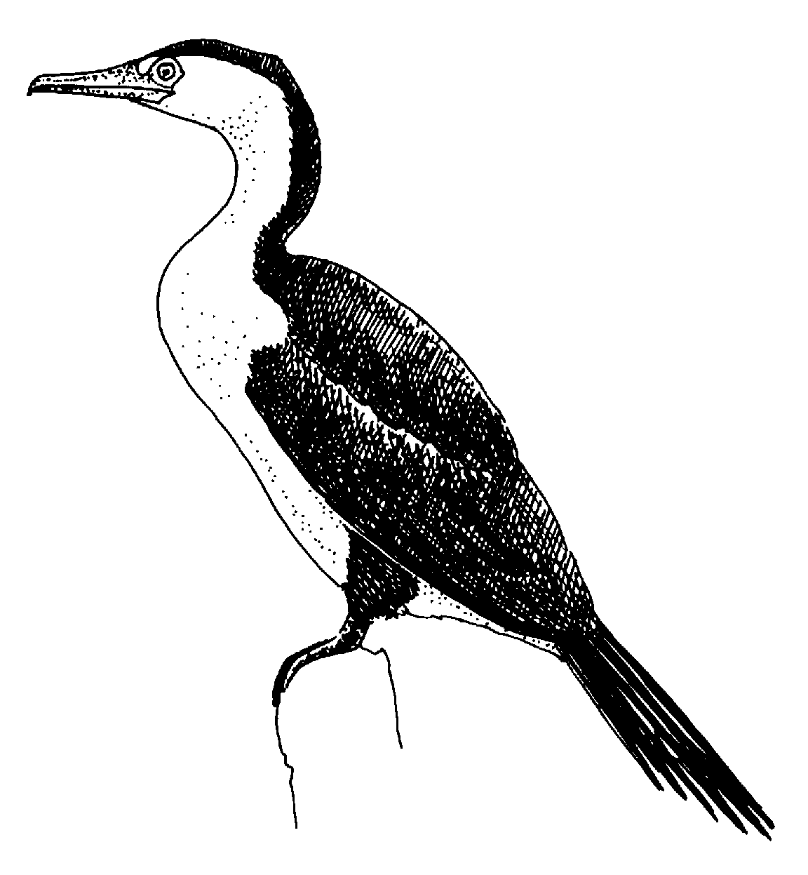 | Pied Cormorant
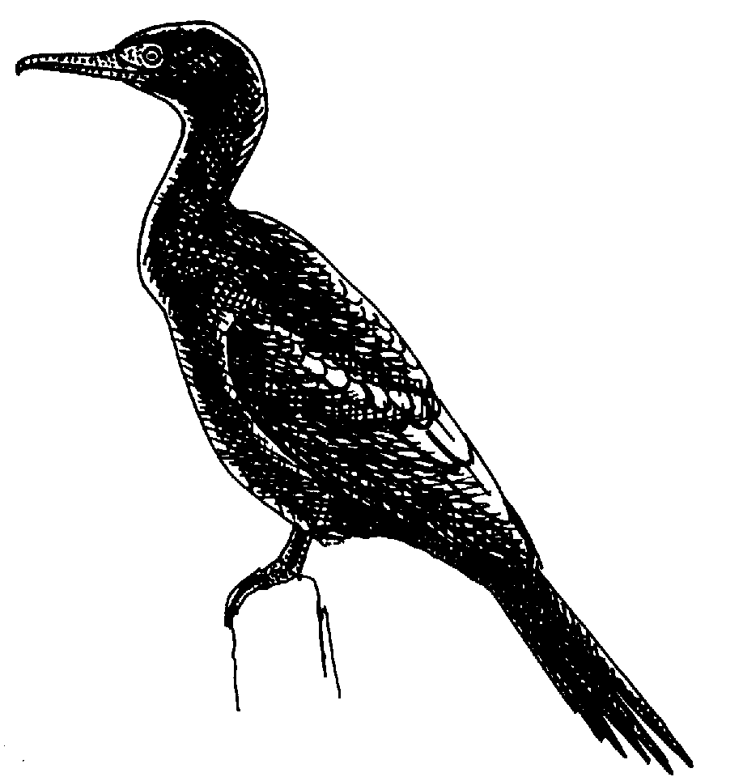 | Little Black Cormorant
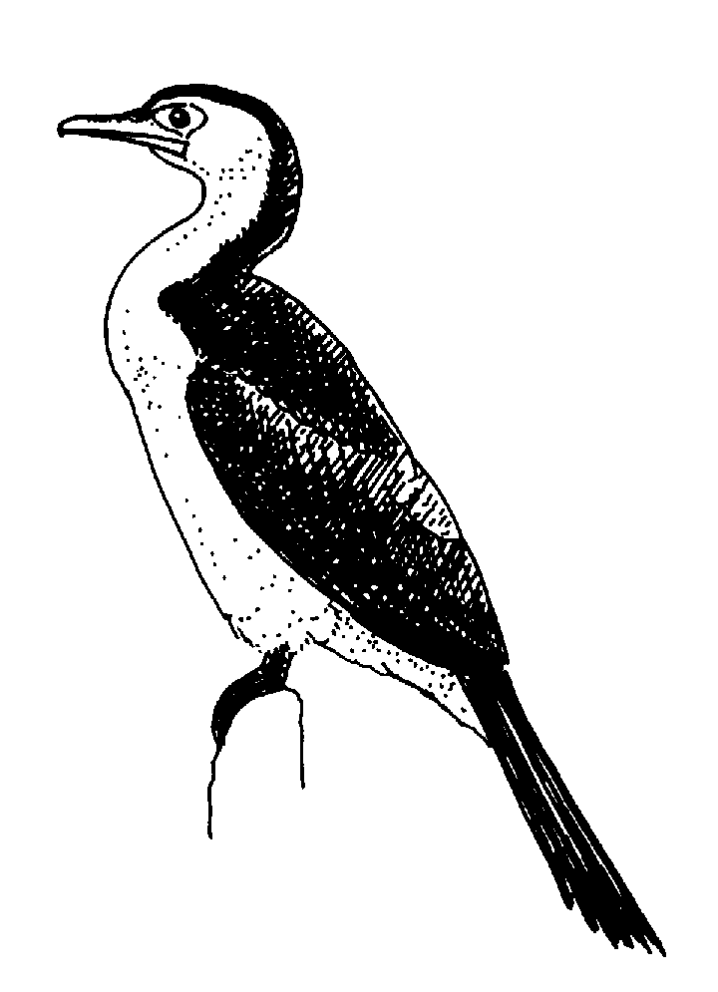 | Little Pied Cormorant
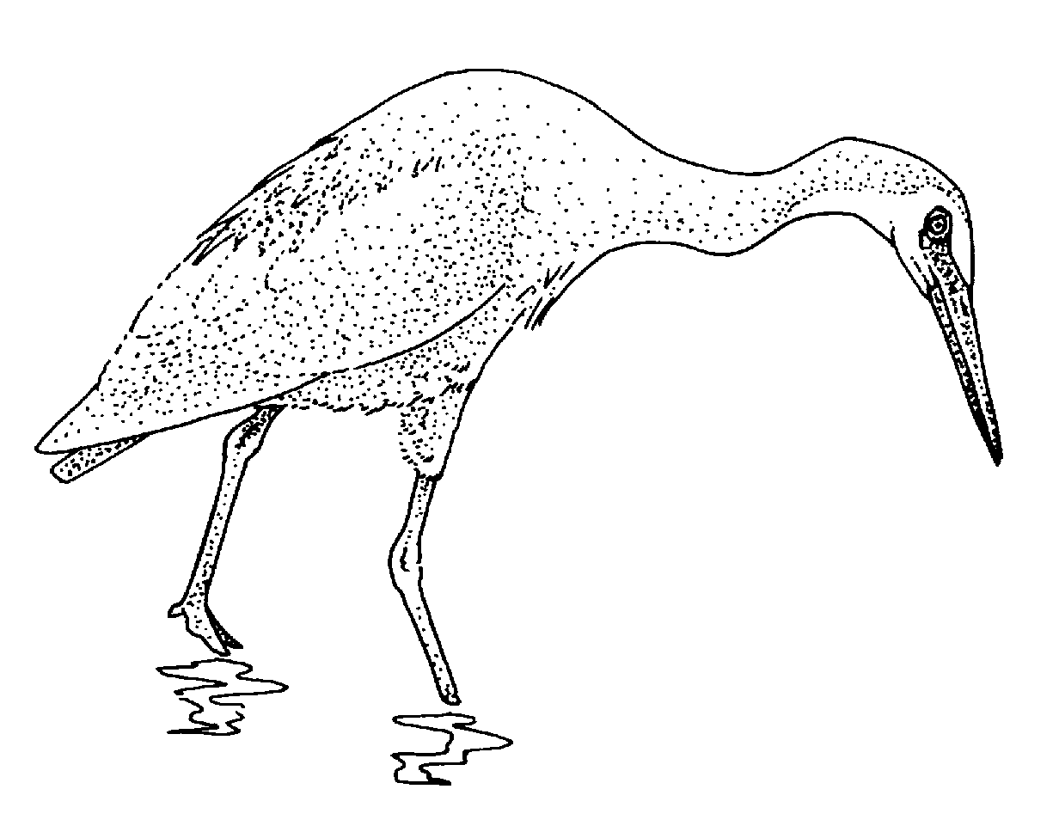 | White-faced Heron
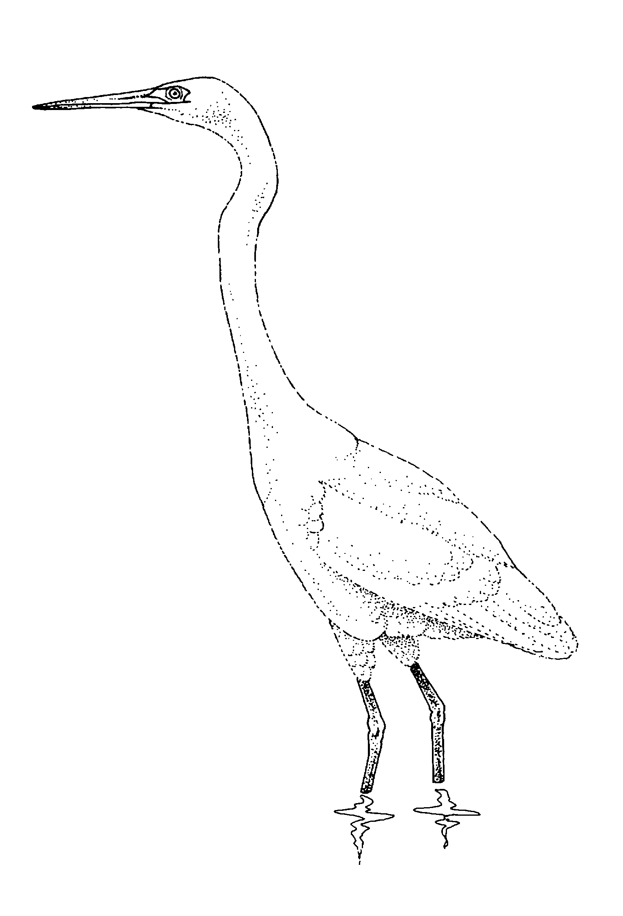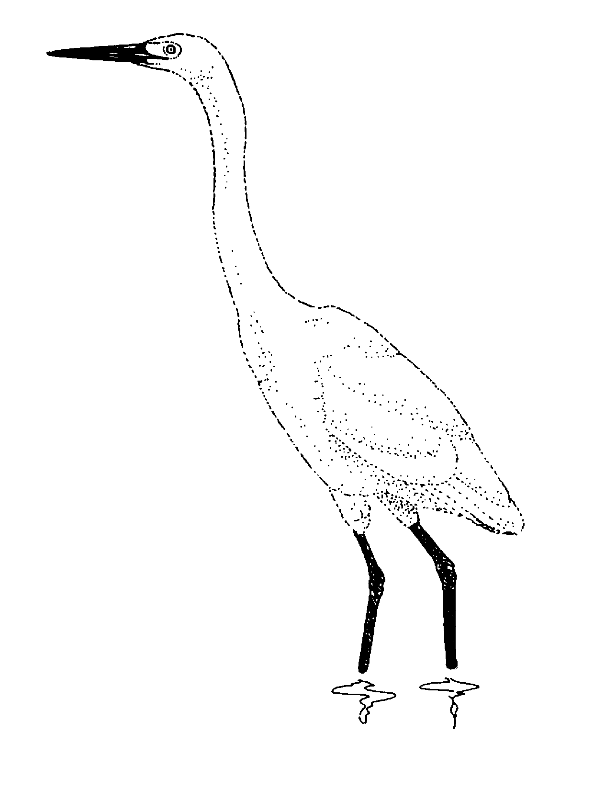 | Egret
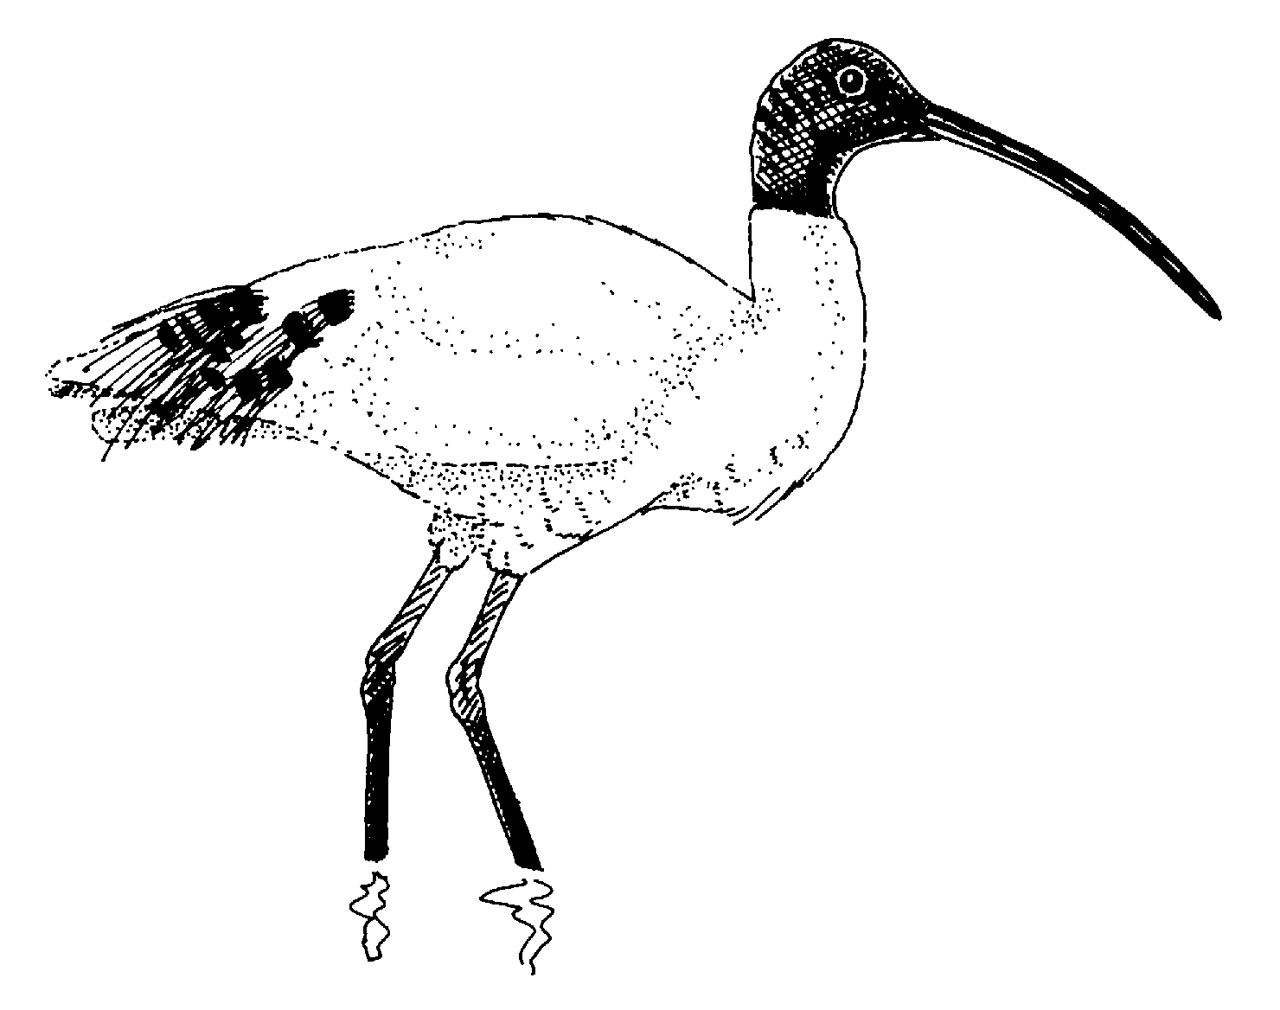 | Australian White Ibis
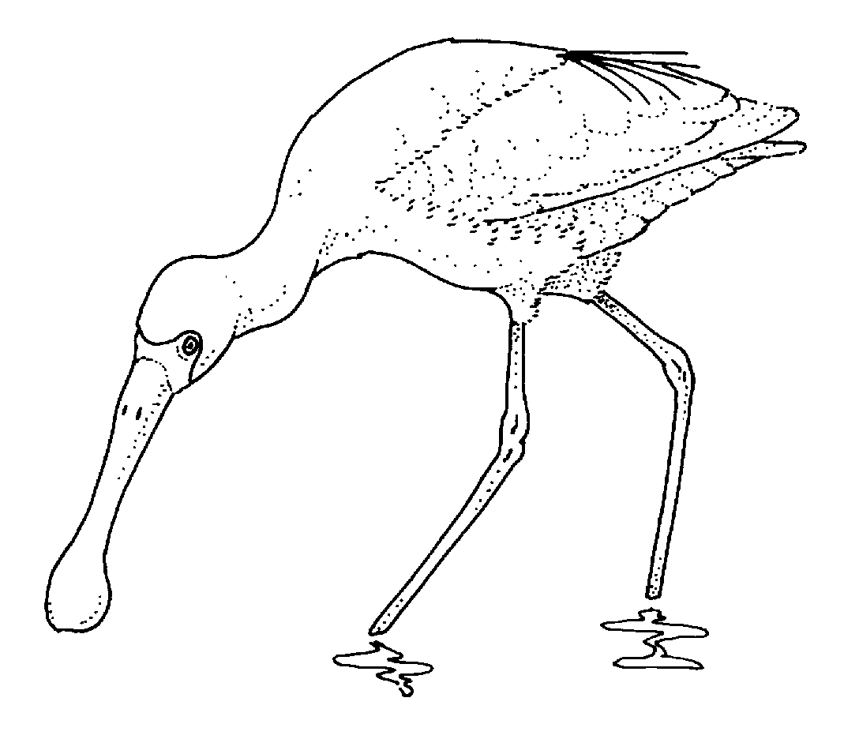 | Yellow-billed Spoonbill
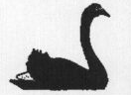 | Black Swan
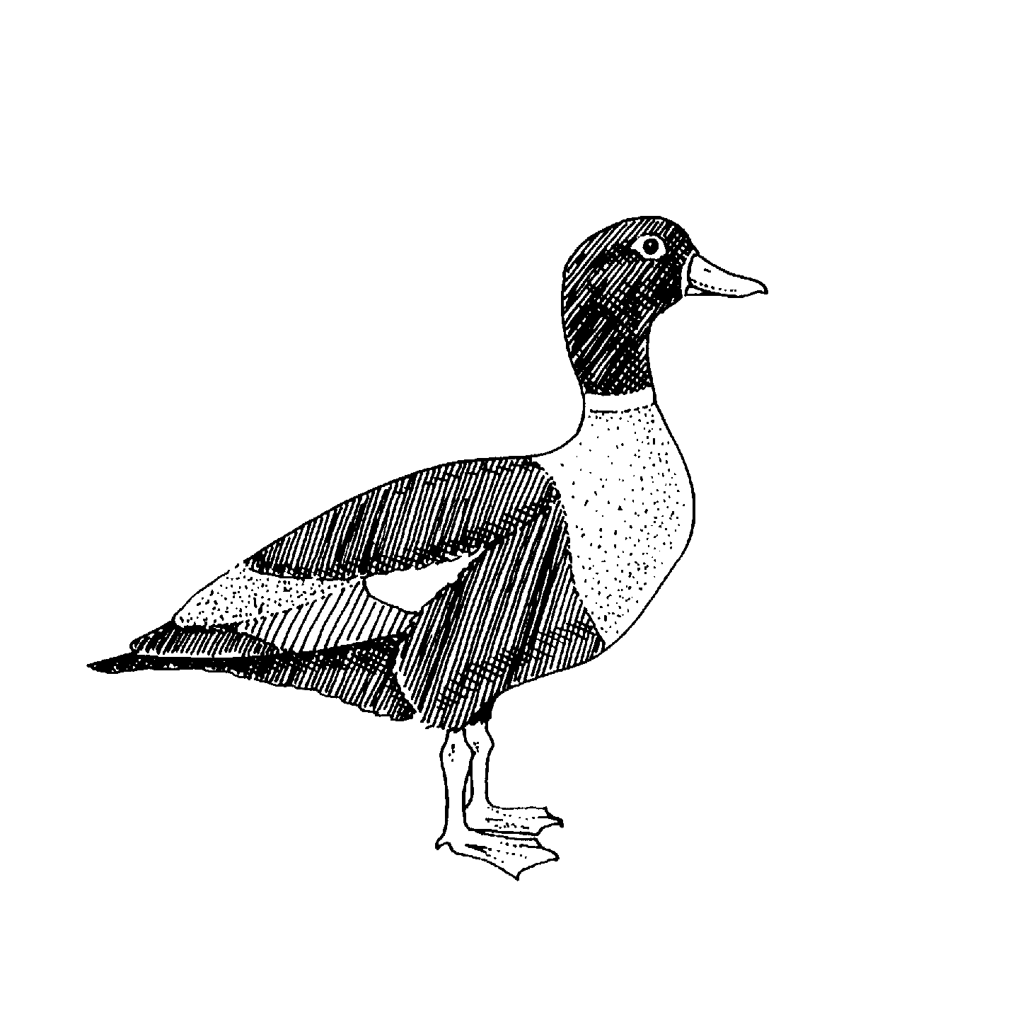 | Australian Shelduck
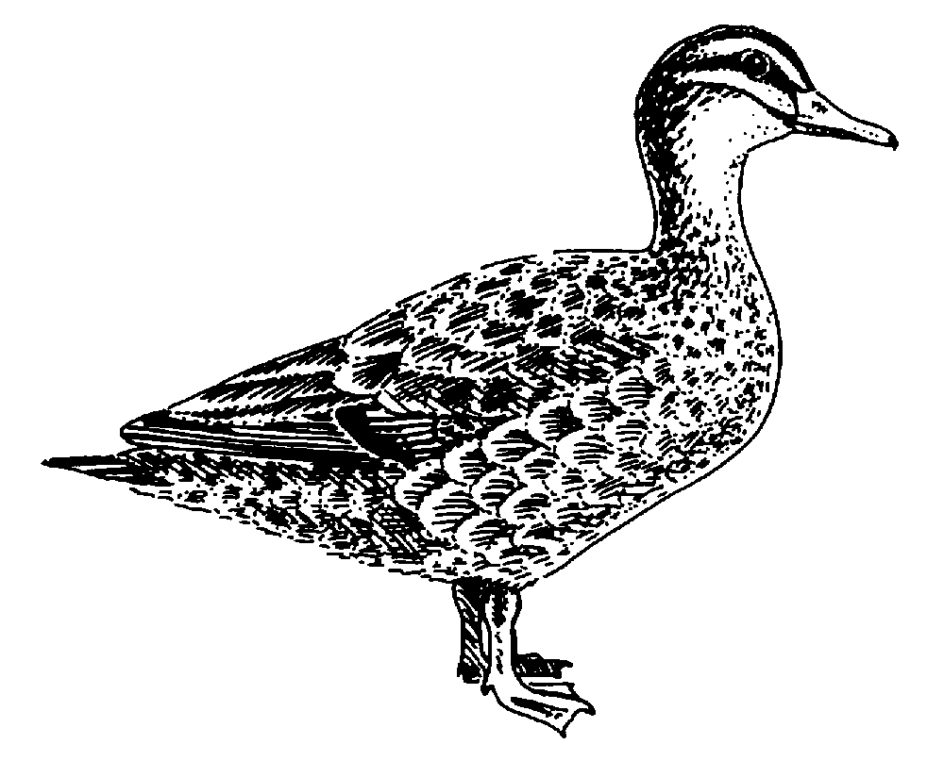 | Pacific Black Duck
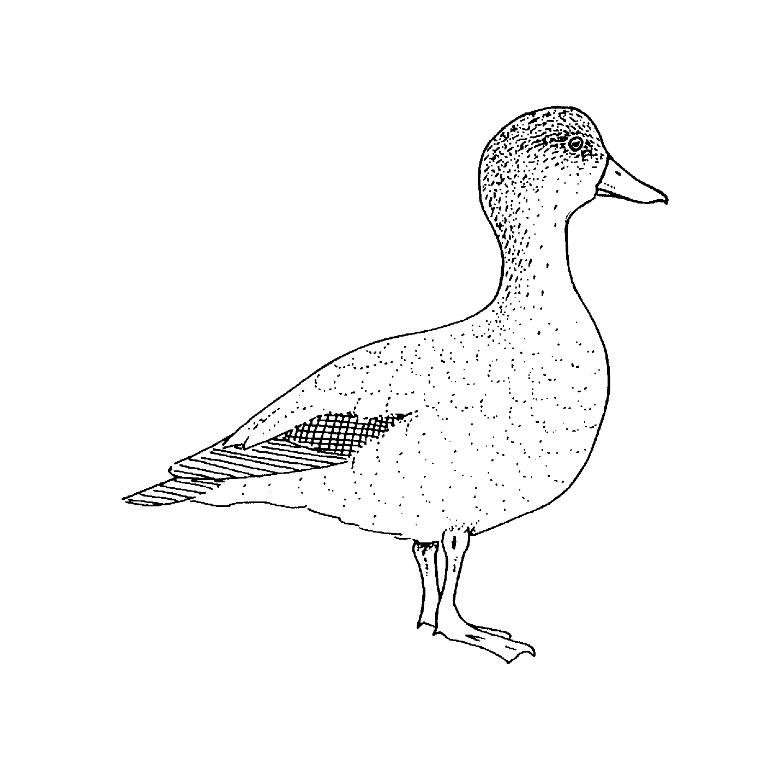 | Grey Teal
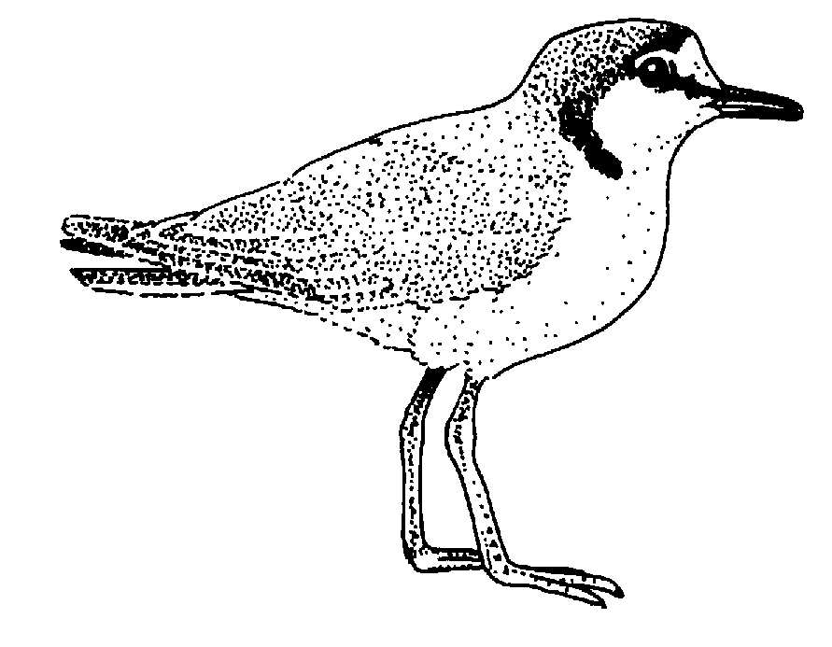 | Red-capped Plover
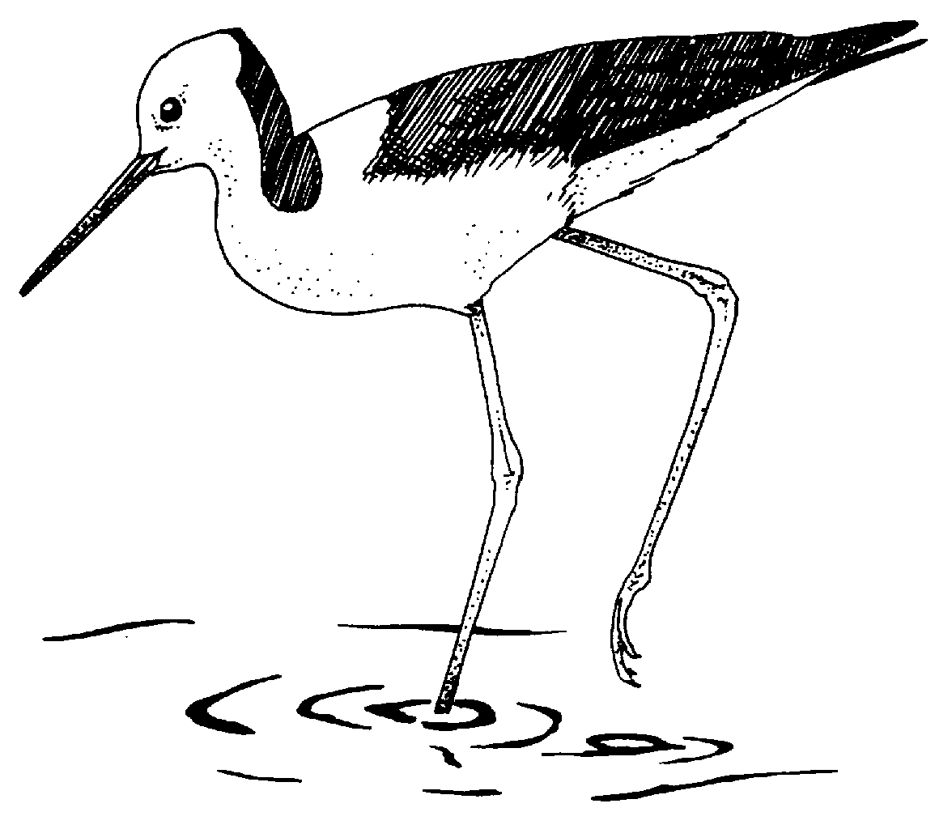 | Black-winged Stilt
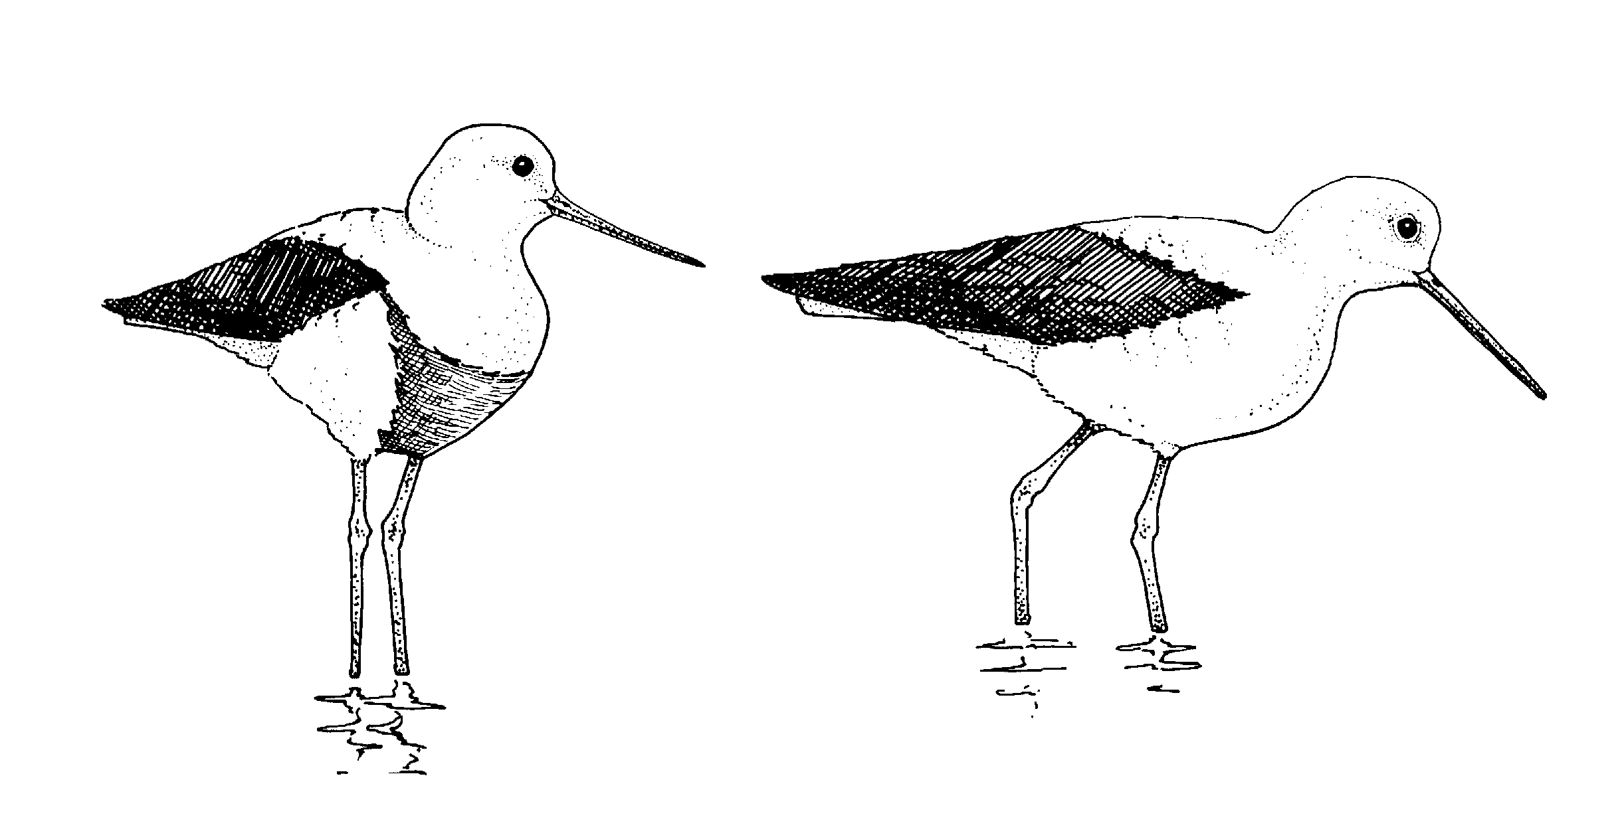 | Banded Stilt
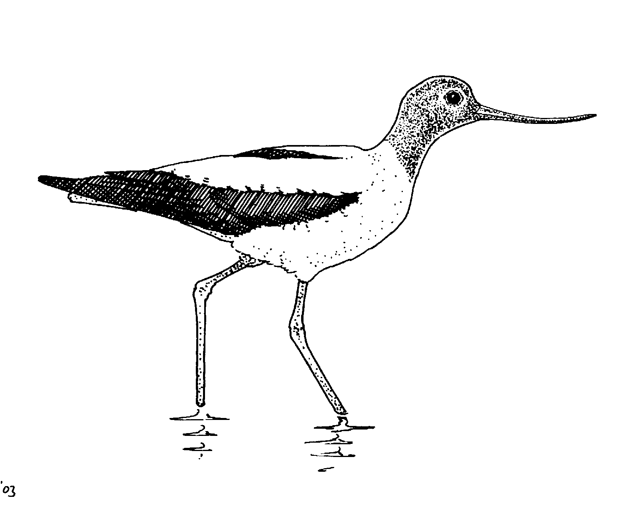 | Red-necked Avocet
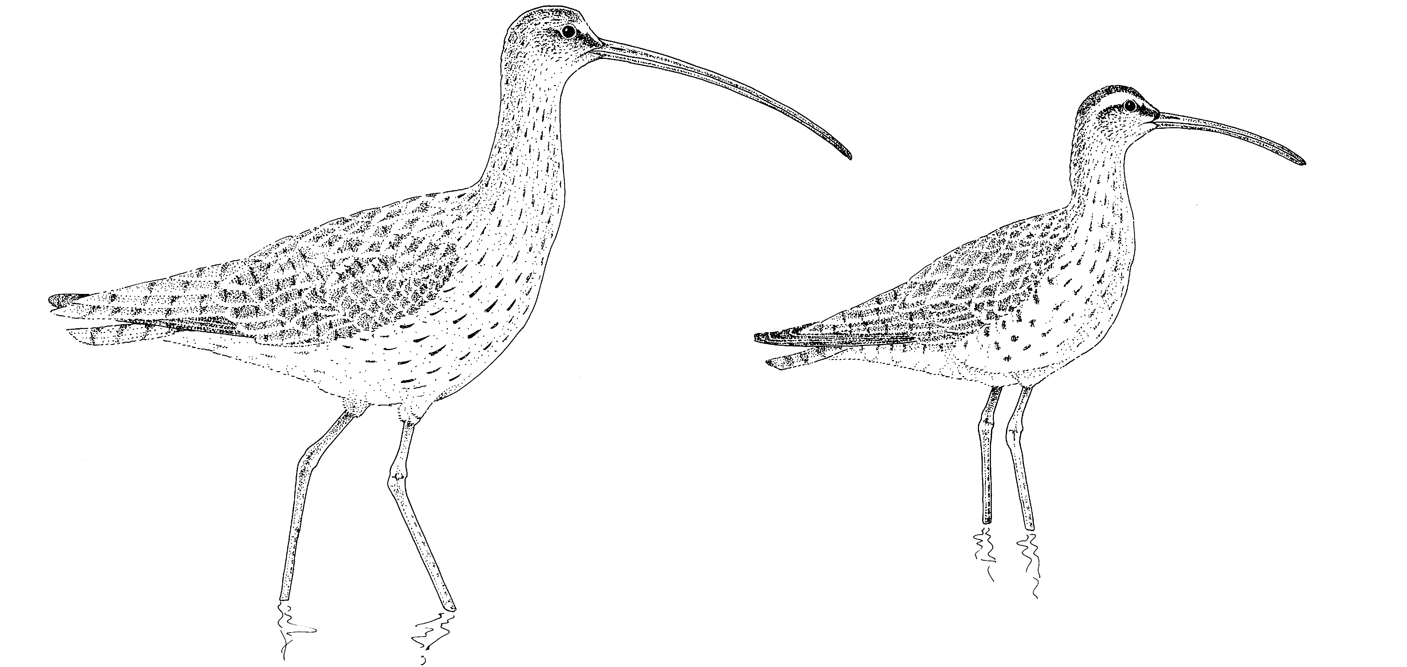 | Curlew or  Whimbrel
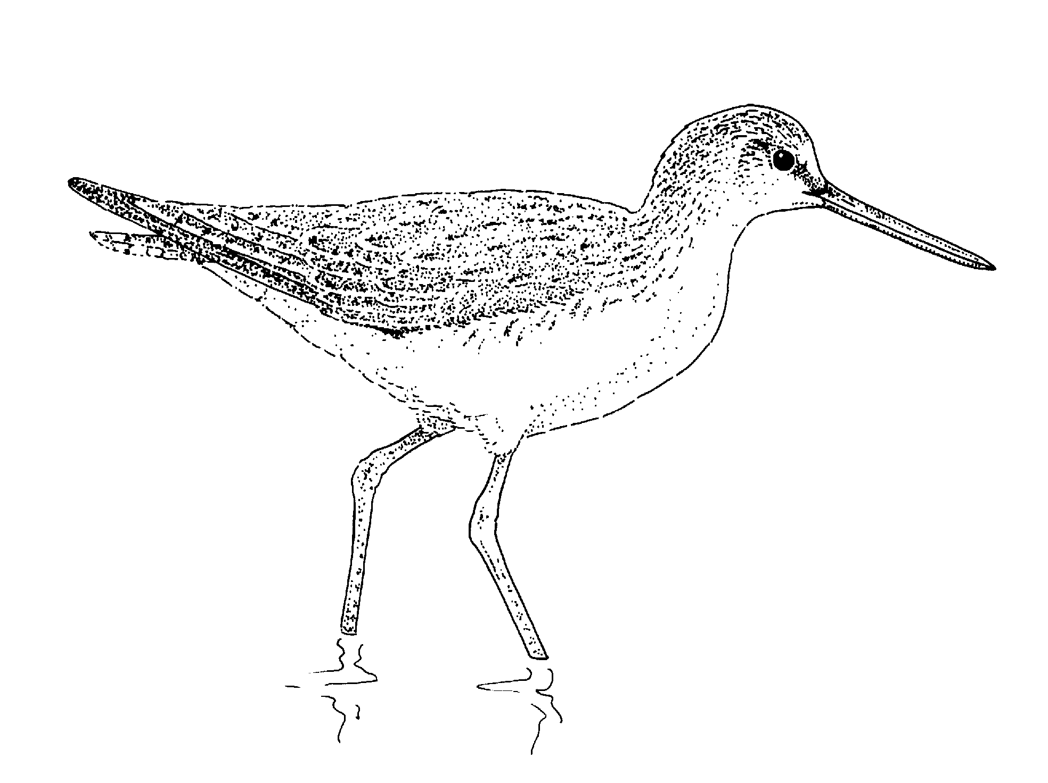 | Common Greenshank
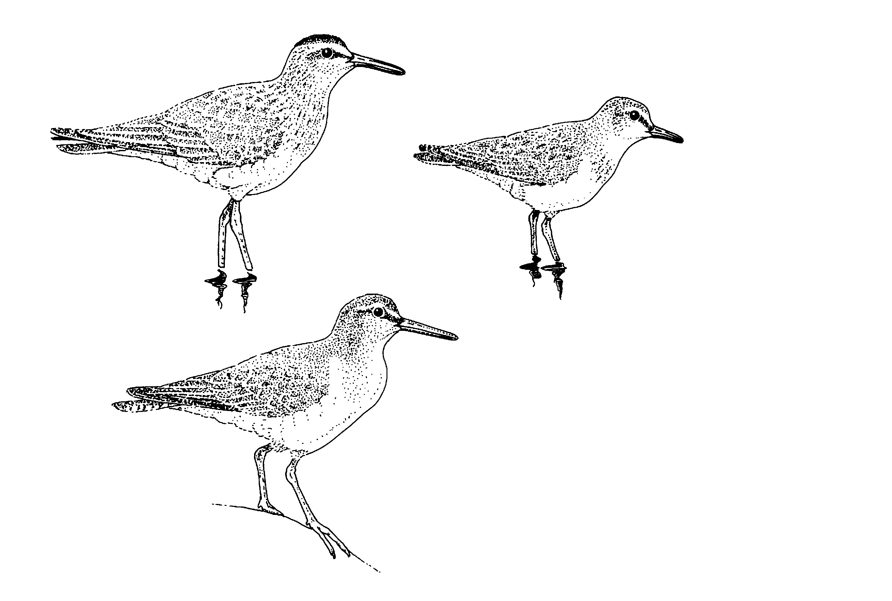 | Small shorebirds (stints, sandpipers)
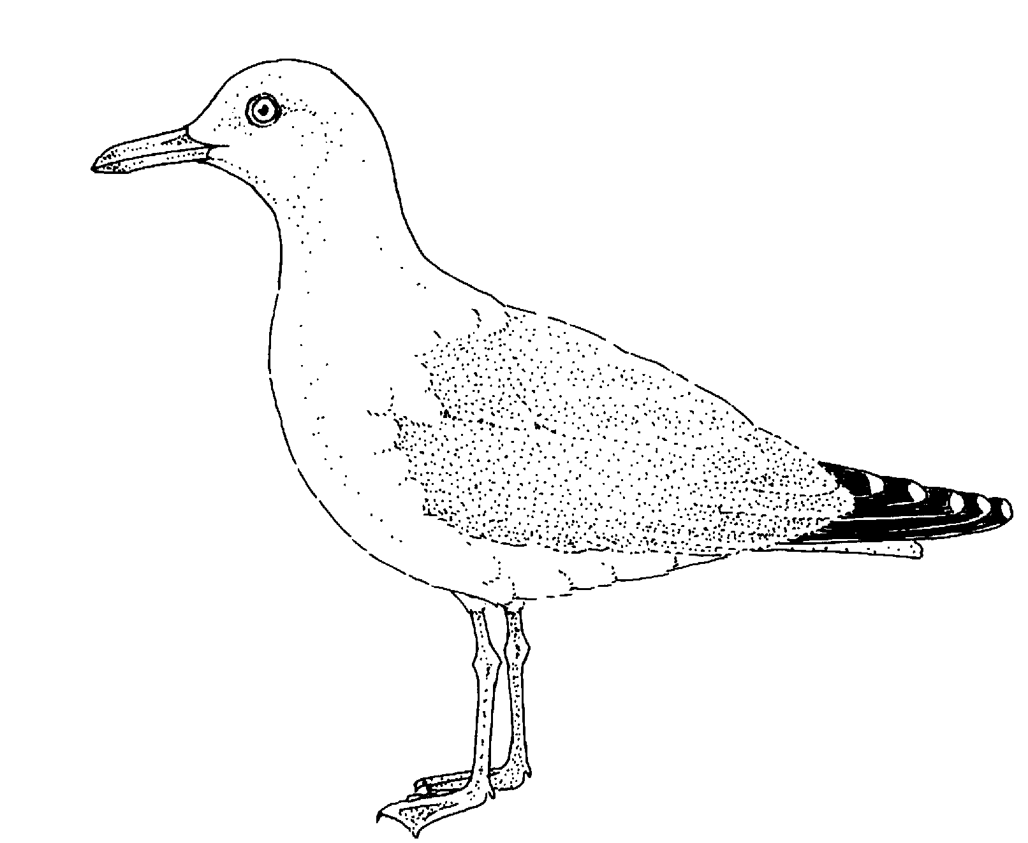 | Silver Gull
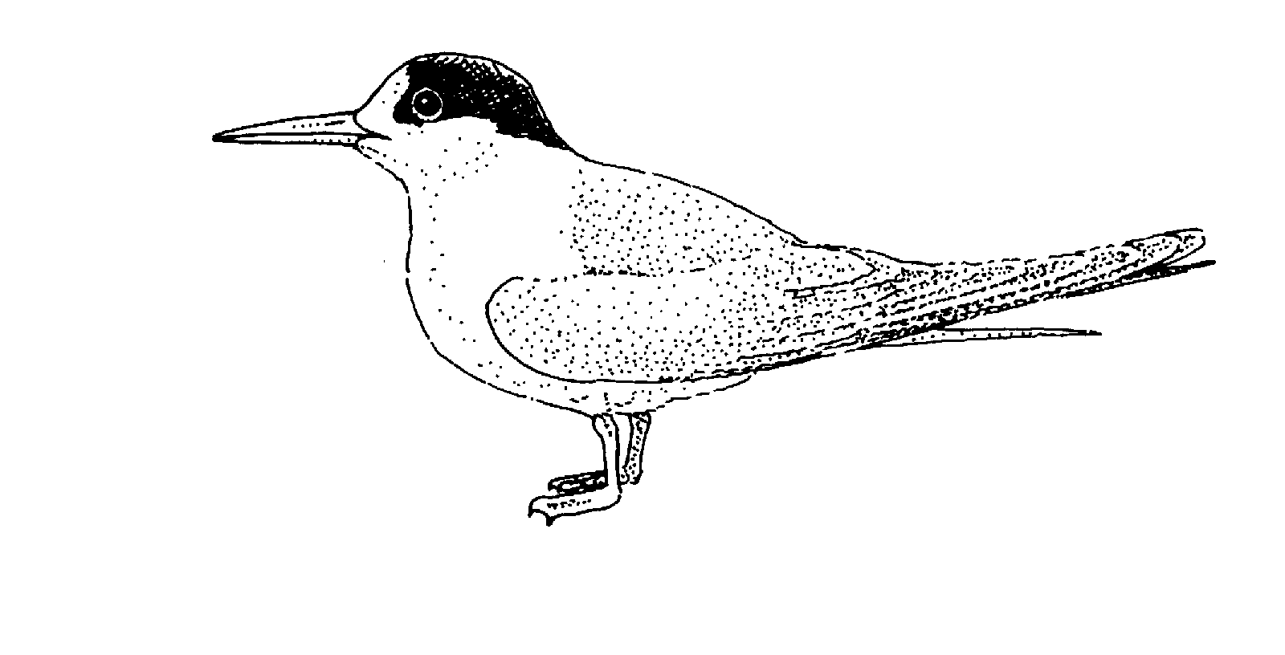 | Fairy Tern
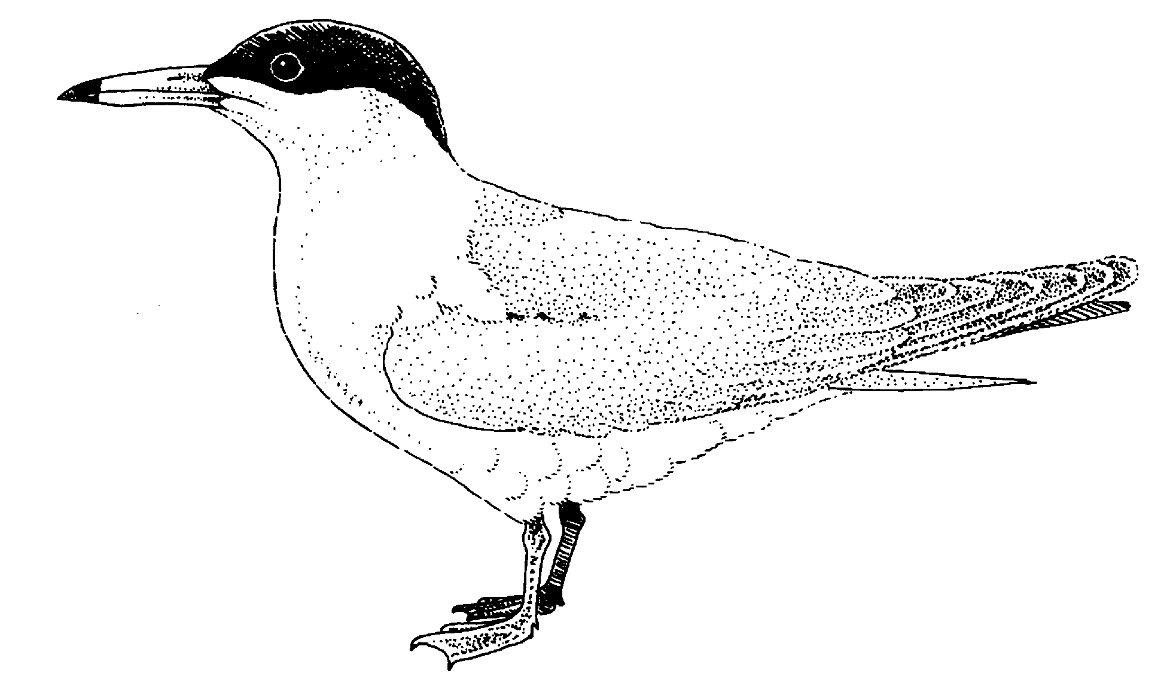 | Caspian Tern
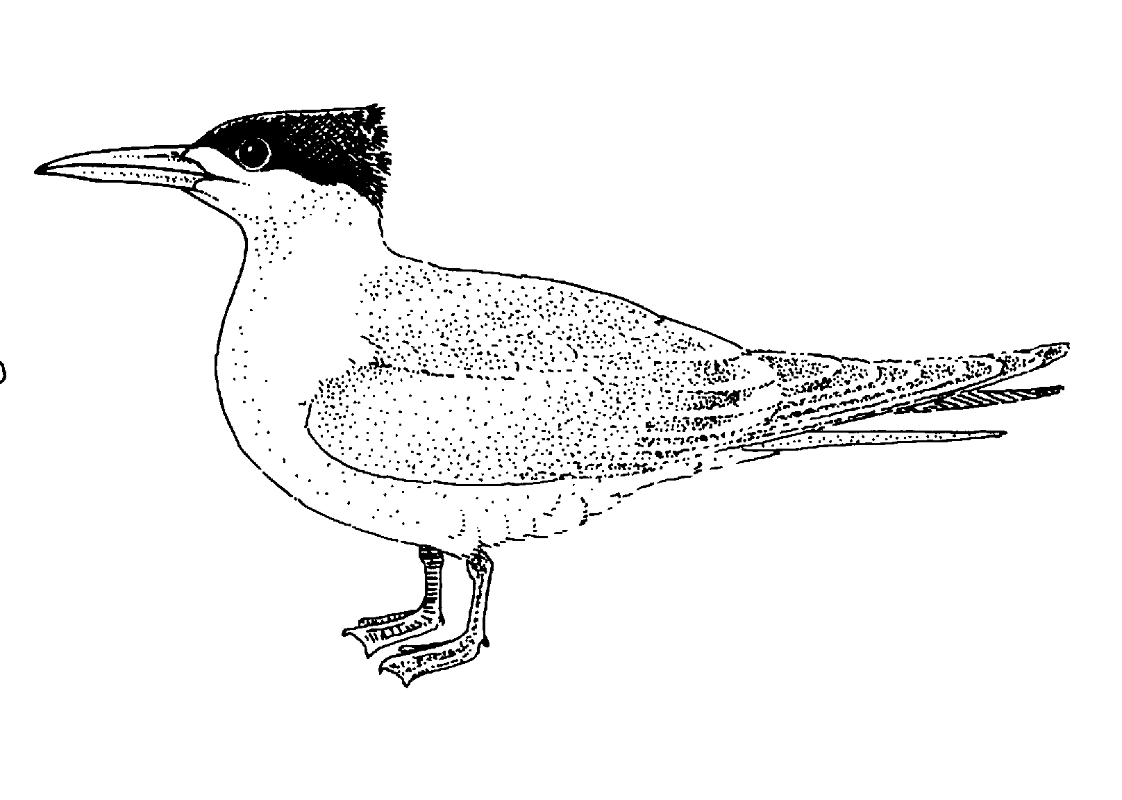 | Crested Tern
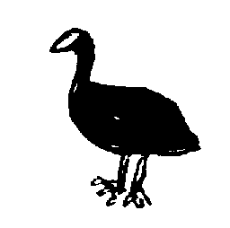

TOTALS

Other Observations:

