Fauna Survey

In this activity you will conduct a fauna survey. Look carefully in the water, on the ground and in the trees for living creatures. Record your findings using the chart below.

Name (if known) or description/sketch | Water | Land | Air
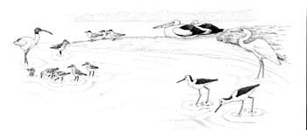

Totals:

