Fun Activities

Choose a native Australian animal that lives around Mandurah. Create some fun activities for younger students to do to learn more about your animal.

For example,
- A word puzzle using www.puzzlemaker.com
- An outline of your animal for a colouring-in in activity
- A game that features native Australian animals
- Other cool ideas that you have – check with your teacher first
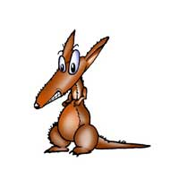

Design a campaign to promote the conservation of Mandurah’s wetlands.

For example,
- Design a poster
- Create and carry out a pollution survey
- Prepare a talk to present to your peers

Replicate an environment that shows a wetland co-existing with an urban development.

For example,
- Construct a model
- Create a poster
- Photograph existing examples
- Written description

