Guidelines for a Wetland Tour

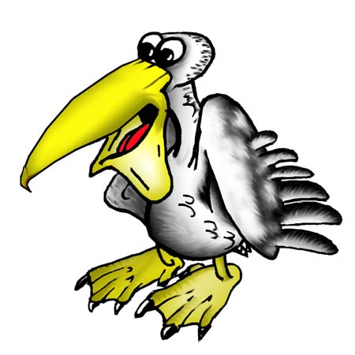
Remember to wear sunscreen and a hat

Wear covered shoes and long pants

Keep to existing pathways

Move slowly and be very quiet

Agree on a special signal for group meetings

Keep within sight of your teacher

Watch out for dangers

Share your interesting findings with others

Have fun

