Human Impact Survey

As you walk around the reserve, what evidence can you see of the impact of humans on the environment?

Human Impact
List positive human impact to wetland environment (boardwalks, signs, etc) | List negative human impact to wetland environment (rubbish, pollution, etc)
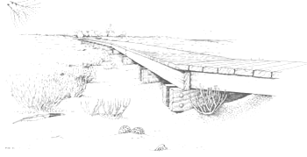

How can we reduce the negative examples of human impact on this wetland?

What else could be done to improve the positive examples of human impact on this wetland?

