My Observations

Use this page to record your observations as you explore.

What I saw  Bobtail | Sketch  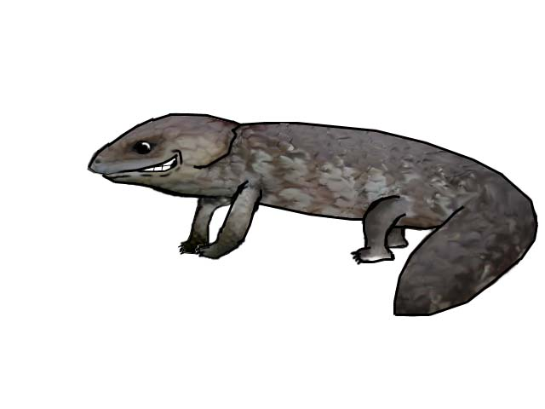

Where I saw it
On path near front gate
What | Sketch
Where | Sketch
What | Sketch
Where | Sketch
What | Sketch
Where | Sketch
What | Sketch
Where | Sketch
What | Sketch
Where | Sketch

