How to Get There

Creery Wetlands Nature Reserve
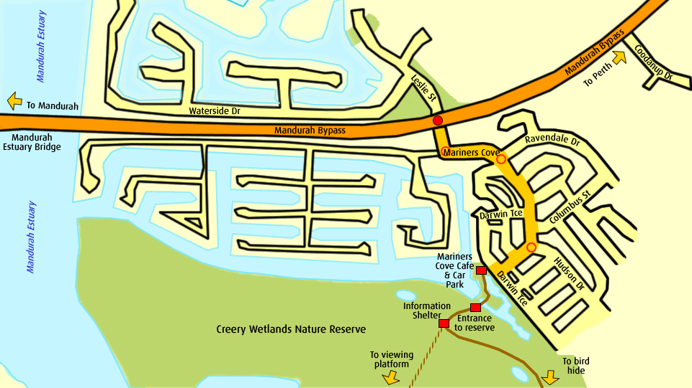

Samphire Cove Nature Reserve
